EJ Cervantes
Deep
CSCI 340
September 2 2019
Lab 1: Wireshark
1. TCP, ARP, DNS.

2. It took about 0.070941448 seconds.

3. gaia.cs.umass.edu – 128.119.245.12
my laptop – 192.168.0.18

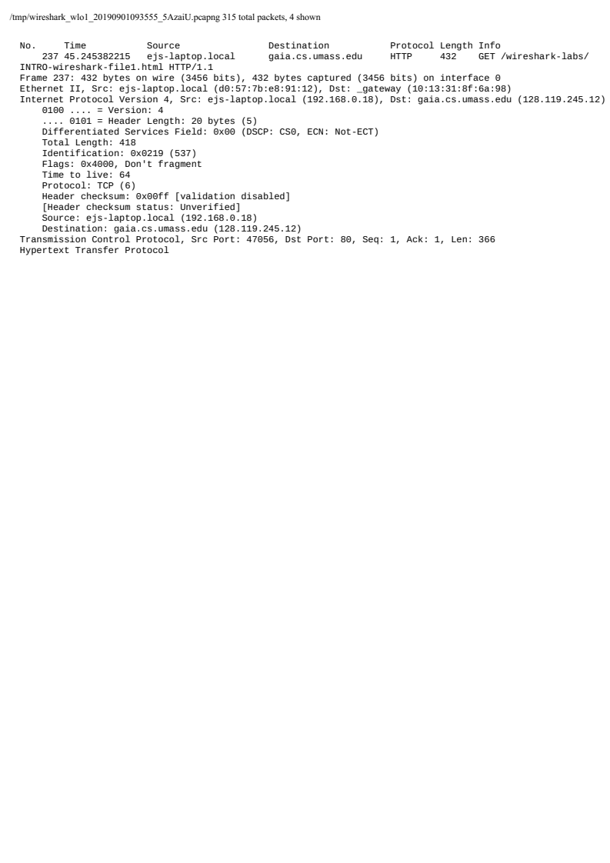
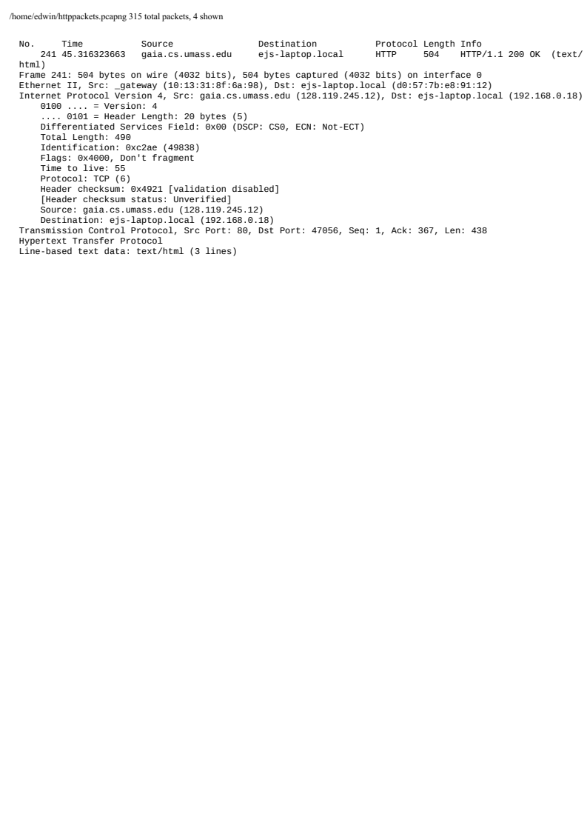
4.

